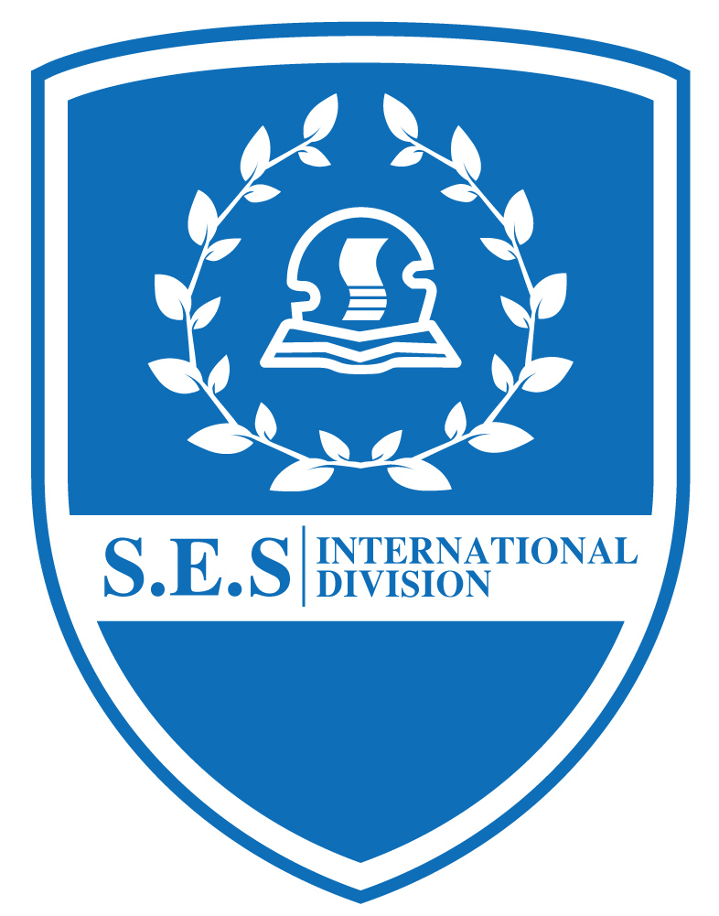
Kids Menu
( Dec 3— Dec 7,2018 )
Date | Day | Menu
Dec. 3 | Monday | 急汁牛肉饼、雪花鸡柳、果酱面包、青椒肉丝银芽、榨菜肉丝蛋汤  Beef pie, snowflake chicken, jam bread, shredded green pepper, shredded mustard and egg soup
Dec. 4 | Tuesday | 扬州炒饭、茄汁菠萝咕唠肉、香菇百叶包、芹菜肉丝、番茄土豆汤  Yangzhou fried rice, tomato juice, pineapple grunt, mushroom louvers, celery shredded meat, tomato potato soup
Dec. 5 | Wednesday | 虾仁炒蛋、酱烧鸭根、黄瓜木耳肉片、油豆腐粉丝虾皮汤  Fried shrimp eggs, roasted duck root with soy sauce, cucumber agaric slices, shrimp skin soup with fried bean curd vermicelli
Dec. 6 | Thursday | 烤鸡翅、鲜茄洋葱肉丝意面、地瓜条、蒜蓉西兰花、罗宋汤  Roasted chicken wings, fresh eggplant, onion, shredded pasta, sweet potato strips, garlic broccoli, borscht soup
Dec. 7 | Friday | 红烧大排、泰汁罗非鱼、花菜肉片、扁尖冬瓜汤  Braised Steak, Thai Juice Tilapia, Cauliflower Meat Slices, Winter Melon Soup

